H.T No
Regulations:
A17

Sreenidhi Institute of Science and Technology
(An Autonomous Institution)
Code No: 6M217 Date: 21-Jan-2019 (FN)

M.Tech I-Year II-Semester End External Examination, Jan - 2019 (Supplementary)
Computational Fluid Dynamics (Te)

Time: 3 Hours Max.Marks:75

Note: a) No additional answer sheets will be provided.
b) All sub-parts of a question must be answered at one place only, otherwise it will not be valued.
c) Missing data can be assumed suitably.

Part - A Max.Marks:25

Answer all QUESTIONS.

1. | Compare the different discretization techniques. Explain the different finite difference schemes. | [3M]
2. | Explain in general the parabolic and hyperbolic nature of the partial differential equations. | [3M]
3. | Discuss the impact on physical and computational fluid dynamics for hyperbolic equation. | [3M]
4. | Define adiabatic wall temperature. Also explain physical boundary conditions for a viscous flow. | [3M]
5. | With the help of diagram, write a note on FVM with a suitable example. | [3M]
6. | Differentiate between linear state fluid flow and steady state fluid flow? | [2M]
7. | What is TDMA? Why is it used? | [2M]
8. | Discuss the basic role of characteristic lines in hyperbolic equations. | [2M]
9. | How Pressure and Velocities are corrected in SIMPLE-R? | [2M]
10. | In order to dissipate heat, a fin is attached to base surface and the other end is free but insulated. For this situation identify the type of boundary condition with a valid reason. | [2M]
Part – B Max.Marks:50
ANSWER ANY FIVE QUESTIONS. EACH QUESTION CARRIES 10 MARKS.

11. | a) | Given the function , calculate and 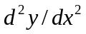 at x=0.3 and 2.5 by second order central, backward and forward differencing. Use step sizes 0.01, 0.1, 0.2 and 0.3. determine the numerical error for each computation. | [5M]
 | b) | What do you understand by stability while solving elliptical equations? Explain with suitable example. | [5M]
12. |  | Consider a two-dimensional plate of 1cm thick as shown in the figure below. The thermal conductivity of the plate material The west boundary receives a steady heat flux of and the south and east boundaries are insulated. If the north boundary is maintained at a temperature of 100, use a uniform grid with ∆x = ∆y = 0.1 m to calculate the steady state temperature distribution at nodes 1,6,9 and 12.  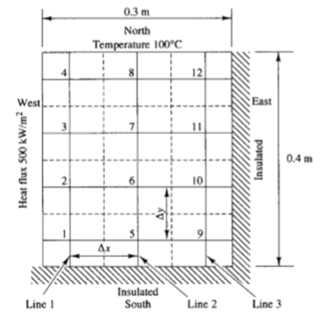 | [10M]
13. |  | Explain the stability behavior of second order wave equation by Von-Neumann stability method. | [10M]
14. |  | Obtain the 2D compressible continuity equation in transformed coordinates for transforming | [10M]
15. |  | Consider a cylindrical fin with uniform cross-sectional area A. The base is at a temperature of 1000 C (TB) and the end is insulated. The fin is exposed to an ambient temperature of 200 C. One dimensional heat transfer in this situation is governed by  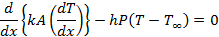  Where ‘h’ is the convective heat transfer coefficient, ‘P’ the perimeter, ‘k’ the thermal conductivity of the material and the ambient temperature. Calculate the temperature distribution along the fin using five equally placed control volumes. Take (note: kA is constant). | [10M]
16. |  | Use two term Glakerin’s method of weighted residuals to obtain an approximate solution of the differential equation Where with boundary conditions | [10M]
17. | a) | Why Pressure velocity coupling is required to solve incompressible fluid flow problems? | [4M]
 | b) | What is the need for grid generation? Mention the different grid generation techniques and list down their relative merits and demerits. | [4M]
 | c) | Explain the general methods of determining the classification of PDEs. | [2M]

-- 00 -- 00 –

